Name: Ritika Mohan
Prn: 23070521183
Semester: 5th C (C1)
Aim: JSON Handling and Mini API Mock:
Parse and display JSON data using fetch() or setTimeout(). Load student records or class schedule from a local JSON file and display them in a table dynamically.
Output:
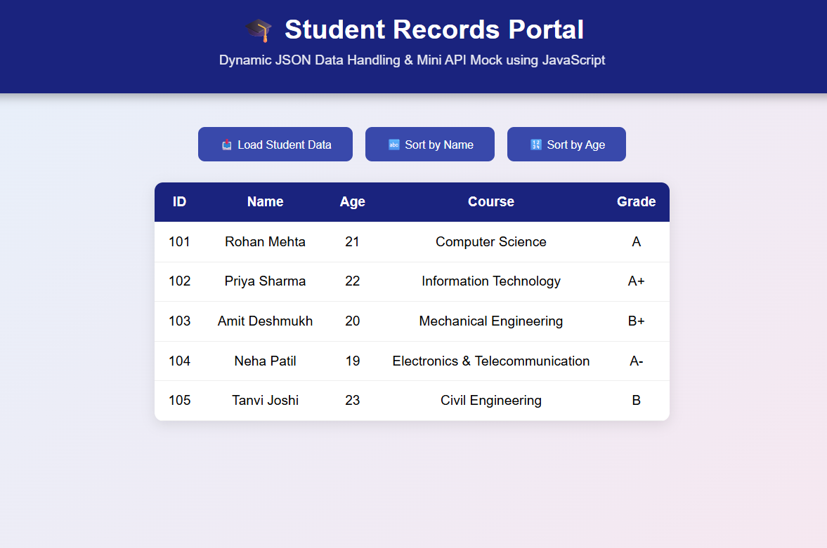
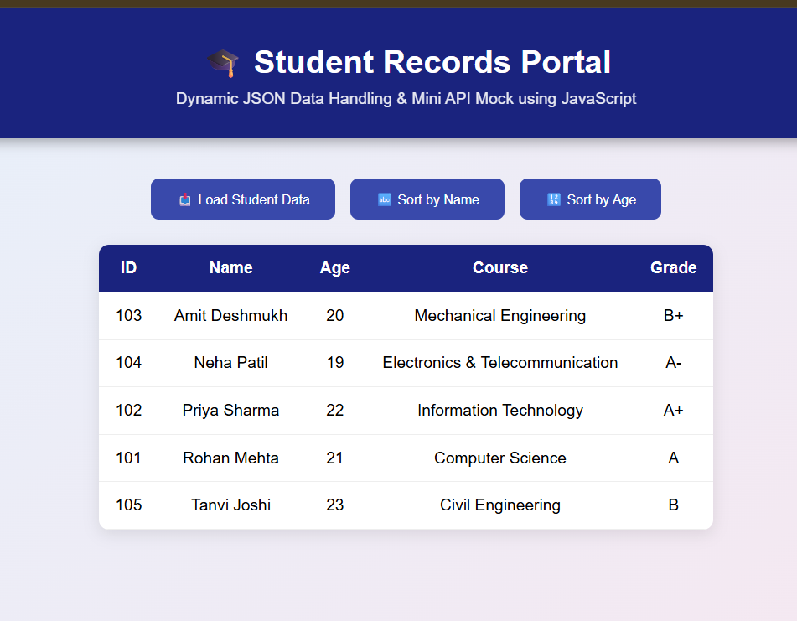
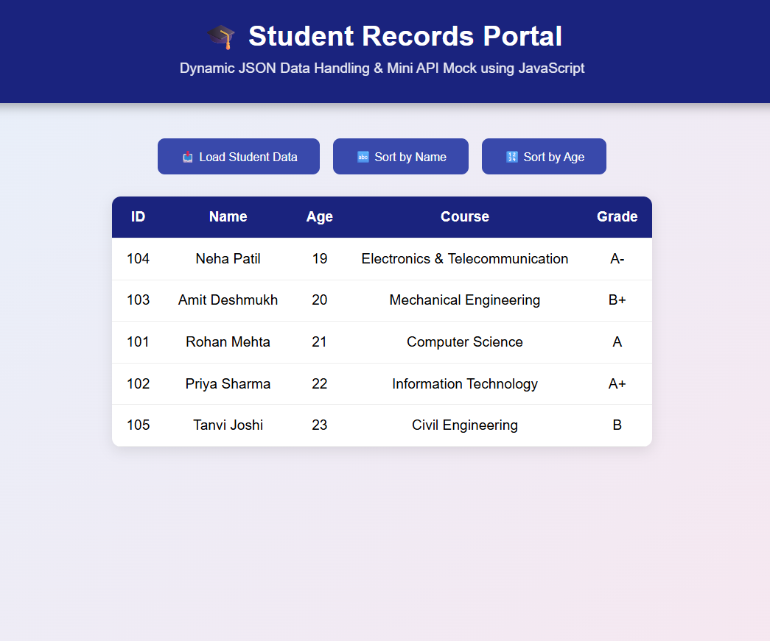
Conclusion: Hence Loaded student records or class schedule from a local JSON file and displayed them in a table dynamically.

